**Review Worksheet Answers DNA Evidence and Protein Sequencing**

1: State the relationship between DNA, RNA, amino acids and proteins.

(3 marks)

*DNA contains the base sequences for building proteins (1). The DNA is transcribed into mRNA and tRNA is used to translate the code into a sequence of amino acids at the ribosome (1). Amino acids are the building blocks of proteins (1).*

2: How many different amino acids make up proteins?

(1 mark)

*There are 20 amino acids used to build proteins. (1)*

3: When comparing amino acid sequences, scientists use a single letter rather than the three letters that are usually used to identify them. Why do scientists do this?

(2 mark)

*Coding the amino acids this way makes it simpler to read and compare the sequence (1), especially where the sequence is long. (1)*

4: Ubiquitous proteins sequences are often compared to assess relatedness and common ancestry between organisms.

1. Define ‘ubiquitous protein’.

(1 mark)

*A ubiquitous protein is a protein found in all known species, performing the same function.*

1. Give an example of a ubiquitous protein.

(1 mark)

*Cytochrome C.*

1. Cytochrome C has changed very little over millions of years of evolution. Explain why this might be the case.

(4 marks)

*Cytochrome C performs an essential step in cellular respiration (1). Any mutation that substantially changed the structure would cause death and therefore not be passed on (1). Small changes to base sequence and therefore amino acid sequence that do not affect the function of the protein (1) would be passed on (1), and accumulate in different ways in different evolutionary pathways over time (1).*

5: What is bioinformatics?

(3 marks)

*Bioinformatics is the use of computers (1) to describe the molecular components of living things (1). It uses biochemical analysis to gain information about DNA and proteins and computer software to store and analyse it.(1)*

6: What is annotation, and why is it part of bioinformatics?

(4 marks)

*Annotation is the identification of genes in a DNA base sequence (1). It does not say what the gene does, just labels different genes so their base sequence can be analysed later (1). It identifies genes by finding start and stop codons in the sequence (1). The process needs to be computerised because genome sequences are too large to be annotated by hand. (1)*

7: Evolution results from changes in DNA. Given this fact, explain why a comparison of the sequence of amino acids in a particular protein can provide evidence for evolution.

(4 marks)

*Amino acids are the building blocks of proteins (1); their order and number in a protein is determined by the sequence of nucleotides in a gene on the DNA molecule (1). Changes in base sequence are reflected in amino acid sequence (1). The more similar the amino acid sequences, the more closely related the two species are (1).*

8: Which would provide more detailed information? A DNA sequence, or an amino acid sequence? Explain your answer.

(3 marks)

*Each amino acid can be coded for by several different triplet codons (1), so an amino acid sequence may not show every single point mutation that could be present (1). For this reason, a DNA sequence provides more detailed information (1).*

9: Table 10.5 sets out an amino acid sequence from alpha haemoglobin of five different species of animals. Compare each of the amino acid sequences to the one from humans.

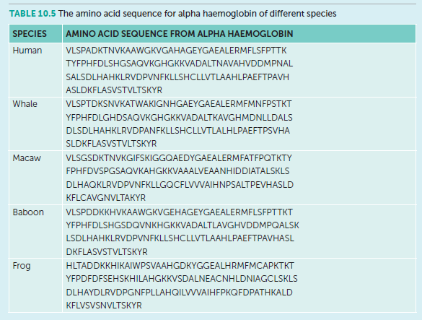

1. Which species’ sequence is the most similar?

(1 mark)

*Baboon is most similar with 11 differences in amino acid sequence compared to humans.*

1. Which species’ sequence is the most different?

(1 mark)

*Frog is the least similar with 58 differences in amino acid sequence compared to humans.*

1. Is this in agreement with current understandings of evolution and common ancestors?

(1 mark)

*Yes, this correlates as the baboon is a primate and belongs in the same family as humans. Frogs are amphibians and phenotypically very different from humans.*

10: Which subdivision of the PNS do I belong to?

“I release ACh at the tissues and have no synapses outside of the CNS”

*Somatic Motor PNS*

“I release ACh at the ganglion synapse, then NAdr (NEpi) at the tissues”

*Sympathetic branch of Autonomic Motor PNS*

“I release ACh at the tissues and my neurons have one synapse outside of the CNS” *Parasympathetic branch of Autonomic Motor PNS*

“My synapses outside of the CNS are organised in ganglia close to the spinal column”

*Sympathetic branch of Autonomic Motor PNS*

“My neurons outside of the CNS are pseudounipolar”

*Sensory PNS*

“I release ACh at ganglia close to the effector tissue”

*Parasympathetic branch of Autonomic Motor PNS*

“I release ACh at a gland that produces Adr and NAdr”

*Sympathetic branch of Autonomic Motor PNS*

“I connect to the spinal cord via the dorsal root”

*Sensory PNS*

“I am often under voluntary control”

*Somatic Motor PNS*

“I run through the ventral roots of the spinal cord along most of the vertebral column and have one synapse outside the CNS”

*Sympathetic branch of Autonomic Motor PNS*

“My cell bodies are in the dorsal root ganglion”

*Sensory PNS*

“My neurons exit the spinal column mostly from the brainstem, and the base of the spinal cord, not from between vertebrae”

*Parasympathetic branch of Autonomic Motor PNS*